Computer Language Coding Concepts

Referrers in a Diagram
The concept of referrers was explained in the article Referrers. This article only explains its display in a diagram.

The referrers of an object are simply displayed as a sub-list called Referrers, every item of which points back to the references to the object:

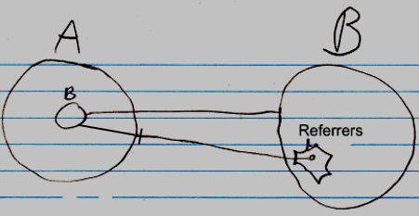

The entry in the Referrers list is pointing to a related item in the parent object A, not directly to an object.

The lines coming out of the referrers list are usually not shown, because a line tied to an object already implies a referrer. The diagrams will have more features later, and the referrer lines would obscure the picture.

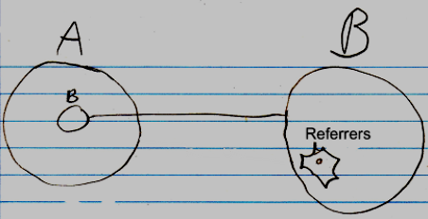

Even the whole referrers list may even be left out of the diagram by default, but it is not clear yet, if that is the way to go.

If something refers to a reference, then this may look like this in a diagram:

b in A is a reference to the reference to c inside B. To display the referrers in the diagram, you could <>do something like this<>:

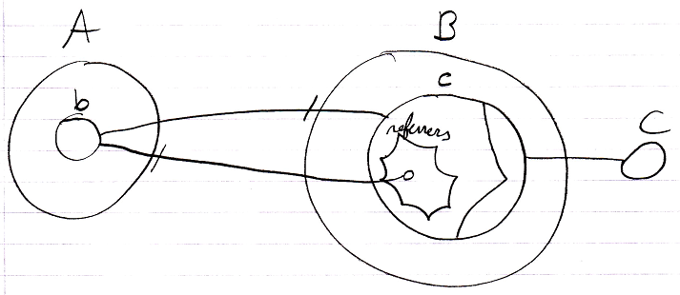

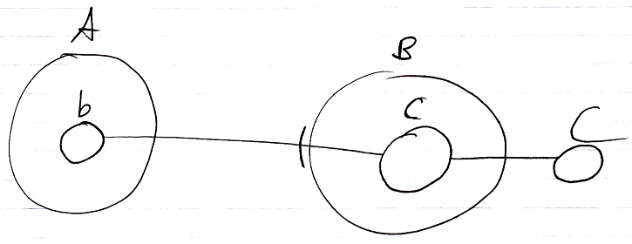

See also: Referrers

Author & Copyright: Jan-Joost van Zon Date: June 8, 2008 – August 17, 2008 Location: Oosterhout, The Netherlands Status: Under Construction

